# CS 255 System Design Document

**Project 2**

**Joey Wheeler**

## UML Diagrams

### UML Use Case Diagram

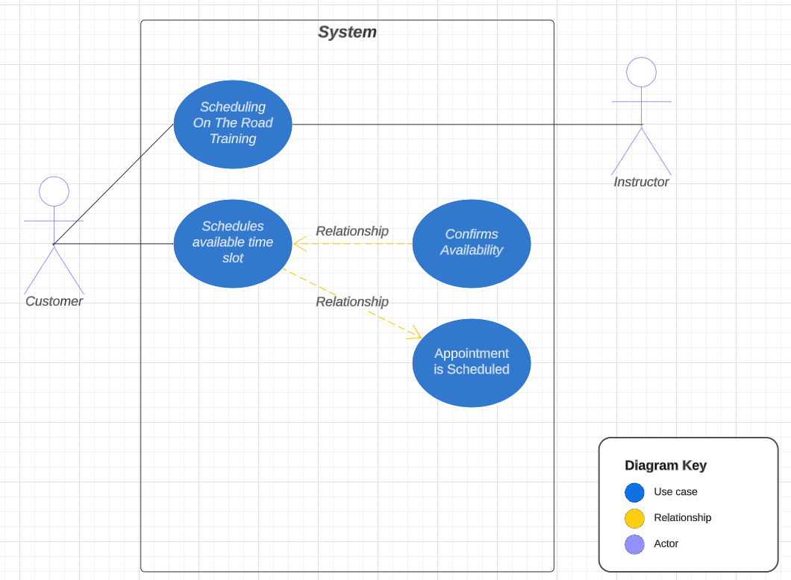

### UML Activity Diagrams

***Use Case 1: Scheduling On The Road Training***

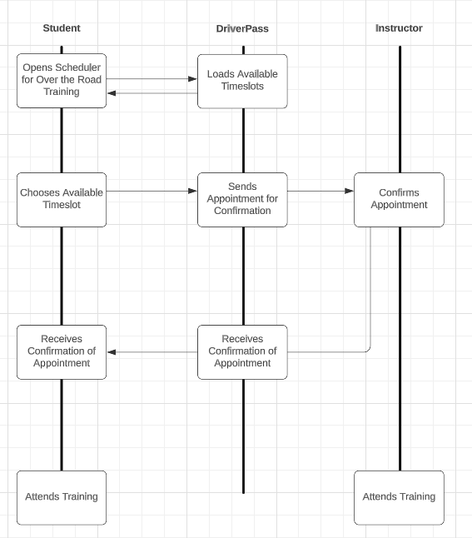

*Use*

***Case 2: Taking Practice Exams***

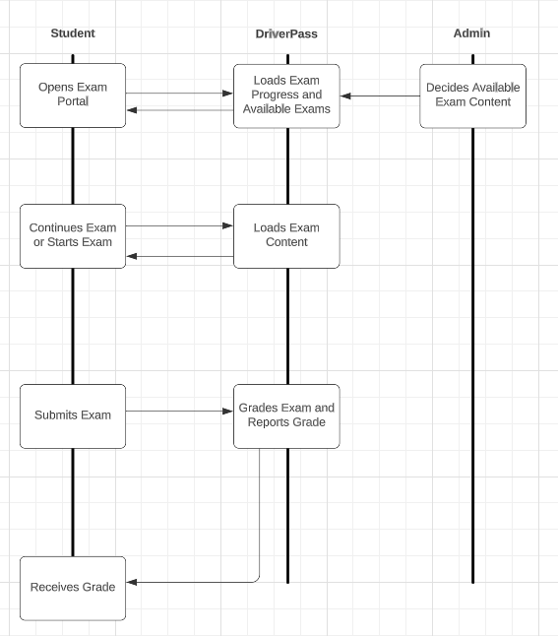

### UML Sequence Diagram

***Case 2: Taking Practice Exams***



### UML Class Diagram

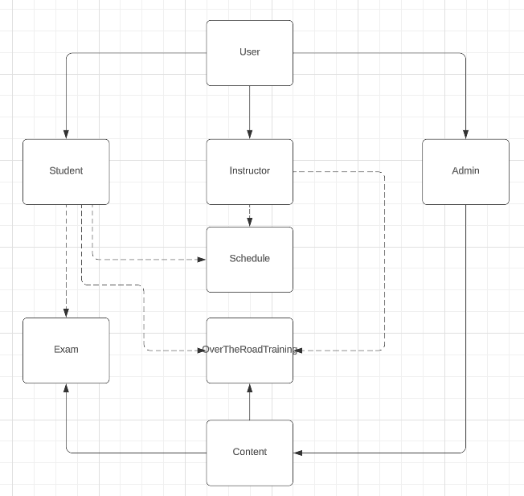

## Technical Requirements

* A database to store scheduling information, user information, and course content.
* A front-end for all users to access the system. Needs to be accessible from both desktop and mobile. Would recommend a web-based front-end that is reflexive enough to view on mobile.
* Server infrastructure to host database and web server.
* Use a 3rd party API to handle payments. This is more secure and easier than handling payments on your own.
* Annual Security audit to ensure site is not vulnerable. A list of corrective actions should be found here and scheduled for implementation.
* A bank account to handle payments, and account with 3rd party vendor using account information.
* UDP based media streaming framework for students to watch online content with best quality.